1. Create Database
2. Design Schema
3. Create tables
4. Insert sample data

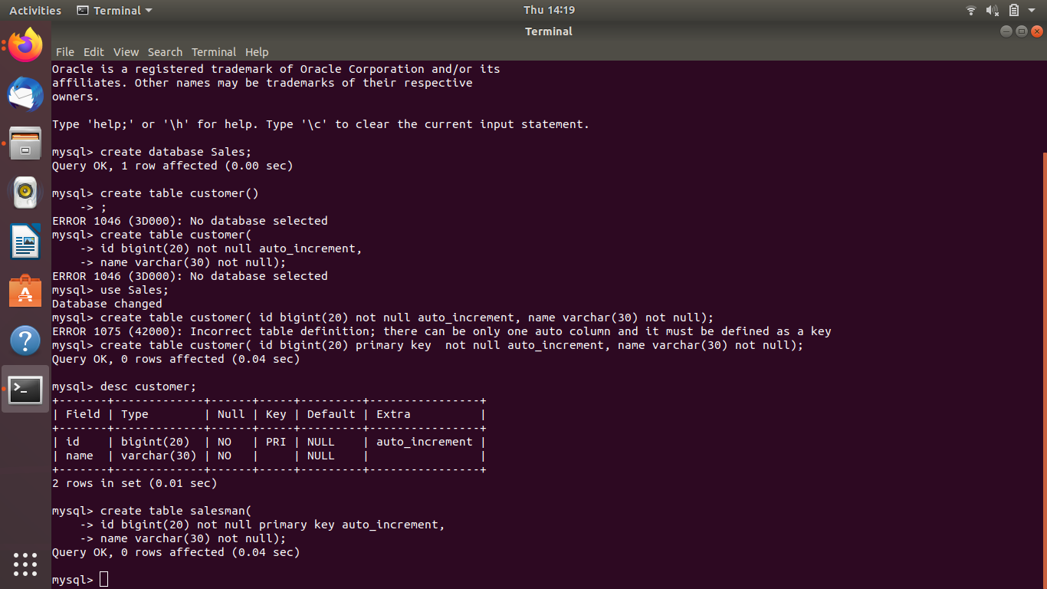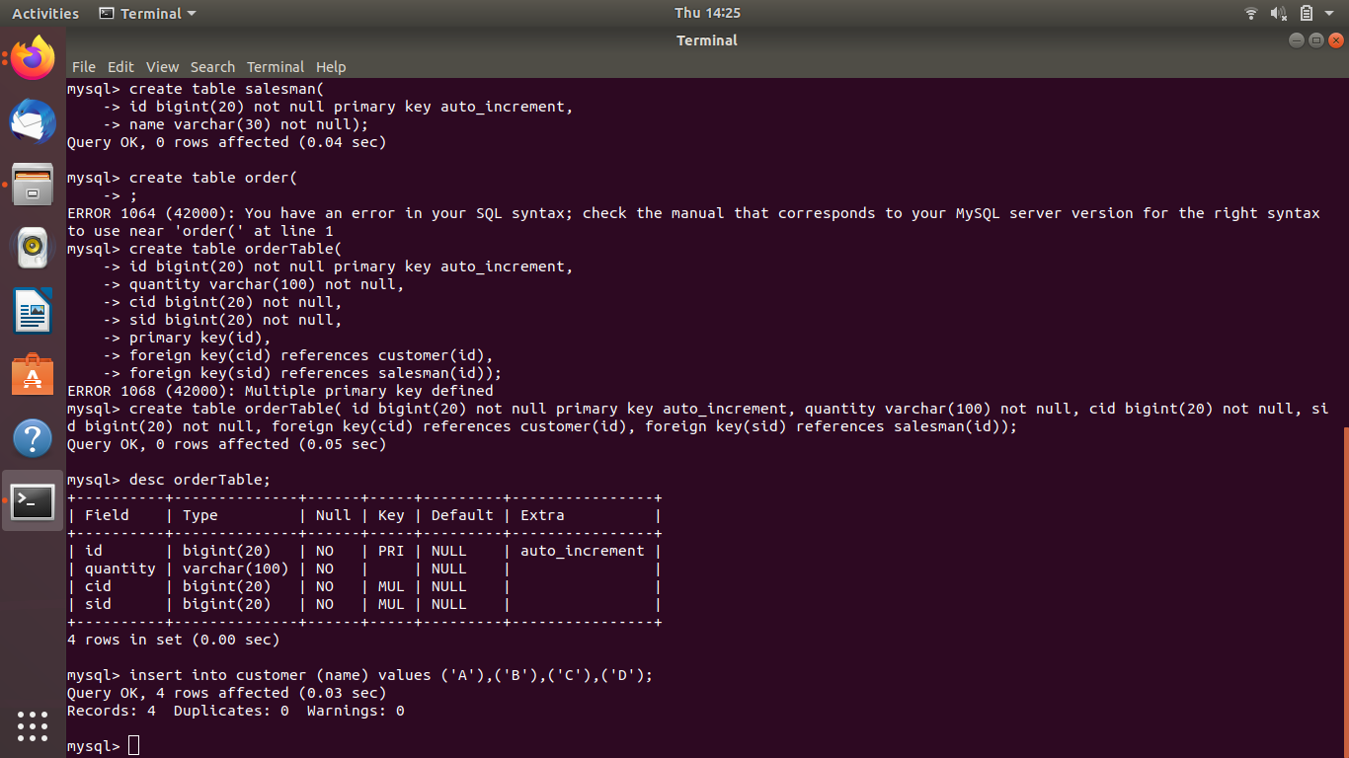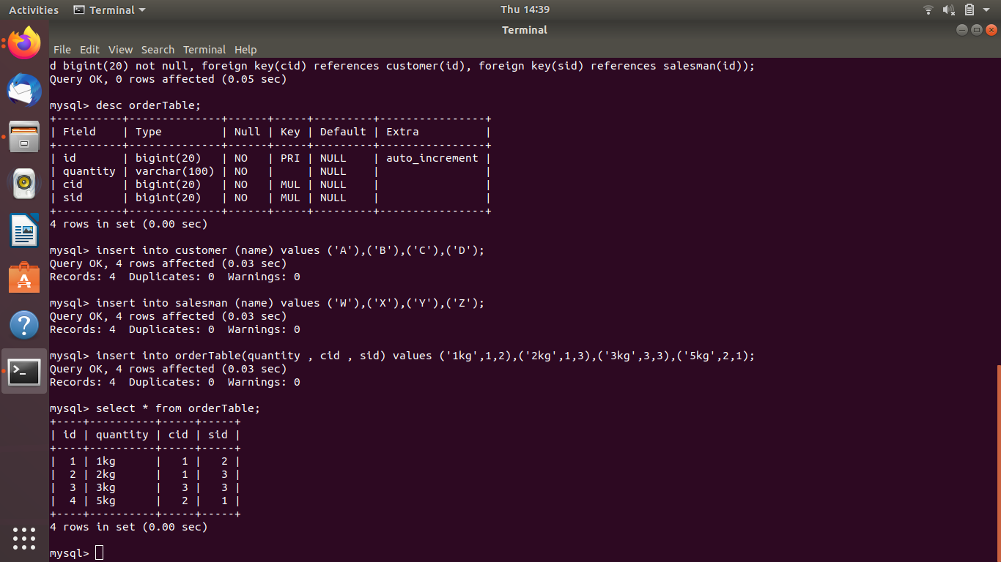

Find the sales person have multiple orders.

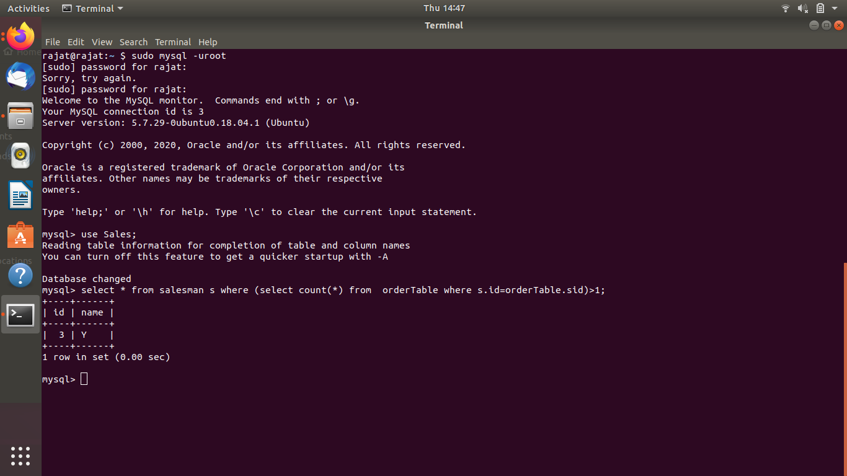

Find the all sales person details along with order details

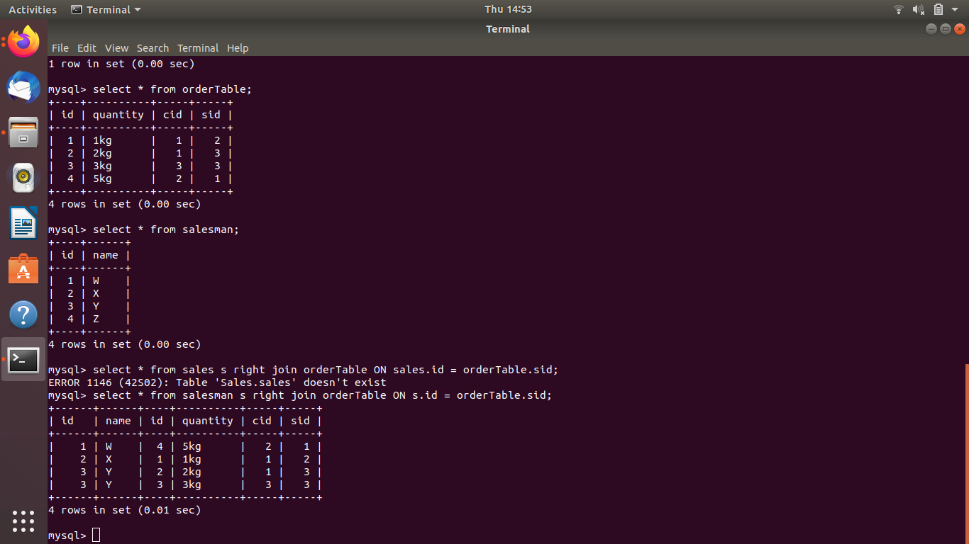

Create index

How to show index on a table

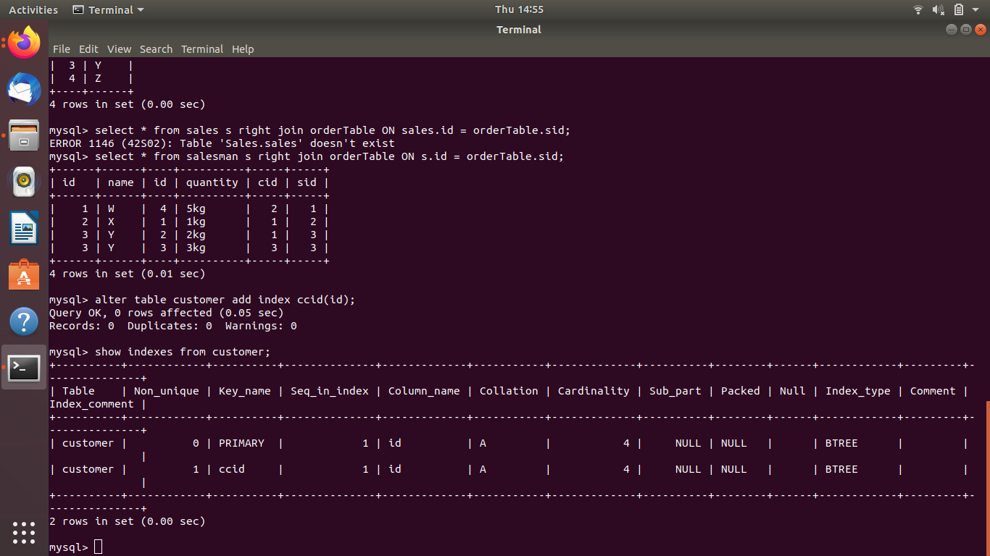

Find the order number, sale person name, along with the customer to whom that order belongs to

